**Cossington Smith, Grace (1892-1984)** (526 words)

Grace Cossington Smith was one of Australia’s foremost female modernist artists. Having developed an enthusiasm for modern theories of colour and design at the Dattilo Rubbo art school in Sydney, in 1915 she exhibited *The Sock Knitter,* a seated portrait of her sister Madge knitting socks for the war effort. Its tight composition and flat blocks of decorative colour, influenced by the modern British style, has led to claims that this may be Australia’s first Post-impressionist painting. Cossington Smith certainly went further than most in exploring the technical challenges and pictorial effects of colour and rhythmic compositional structure. She lived an unmarried, childless and economically comfortable life devoted to art. Living in relative suburban seclusion, Cossington Smith nonetheless held regular and successful solo exhibitions and was loosely involved with Ethel Anderson 's Turramurra Wall Painters. Her broad subject matter includes city scenes as well as portraits of friends and family, religious scenes, landscapes, still life and flower painting. The artist later focused loving attention on the formal and spiritual dimensions of light itself, as registered in the mirrored interior spaces of her beloved home, Cossington. While she always attended to the formal qualities of the motif, her works often contain details of human interest and social commentary.

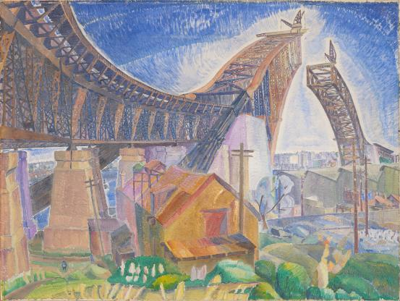

Grace Cossington Smith *The Bridge in-curve* (1930) tempera on cardboard 83.6 x 111.8 cm. National Gallery of Victoria, Melbourne

[**http://content.ngv.vic.gov.au/col-images/large/Dd102252.jpg**](http://content.ngv.vic.gov.au/col-images/large/Dd102252.jpg)

Cossington Smith’s modern viewpoint drew strength from a number of sources, including war propaganda and commercial illustration. The artist’s prodigious drawing skills were honed through an illustrative observation of current events, evident from her early wartime propaganda cartoons. As a child of the Kodak ‘happy moments’ generation, Cossington Smith’s snapshot-style observations of city life, as in *Reinforcements: Troops Marching* (1917) is a tightly-framed view that zooms in on the cute detail or human angle. And as a political conservative and devout Anglican, she responded rapturously to the span of the new Sydney Harbour Bridge, which she depicted as a sublime spiritual and technological masterwork. *The Bridge in-Curve* (1930) looks up from below to the arches of the bridge approaching from each side of the harbour, as if in communion, forming the architecture of the Trinity and haloed by a radiant rainbow of light. Cossington Smith’s landscapes also attend to the formal, decorative qualities of the motif, enabling her to investigate the underlying rhythms of nature itself. Her experimental approach to colour and form freed her from the conventions of naturalistic landscape painting that still dominated Australian interwar art. *Sea Wave* (1931)abstracts the coastal shoreline through rhythmic colour composition, as a means to transcend the material, everyday world and seek connection with the Divine.

**References and further reading**

Eagle, M. (1990) *Australian Modern Painting between the Wars 1914-1939*, Sydney: Bay Books (a good survey of Australian modern painting)

Hart, D. (2005) *Grace Cossington Smith*, Canberra: National Gallery of Australia, (a scholarly exhibition catalogue with fine essays on the artist and her work)

Modjeska, D (1999) *Stravinsky’s Lunch*, Sydney: Picador. (A comparative discussion on the art and lives of Cossington Smith and Stella Bowen).

Topliss, H. (1996) *Modernism and Feminism: Australian Women Artists, 1900-1940*, Sydney: Craftsman House (A thoughtful survey of Australian women modernists)